NAME: SHASHANK NAGUMANTRI
ROLL NO: 19B21A05C3
E-MAIL ID: shashankn7261@gmail.com
SUBJECT: Full Stack Data Science (Assignment 1)
ANSWERS
Q1.
Ans: Values: ‘hello’, -87.8, 6
Expressions: *, -, /, +
Q2.
Ans: Strings: A string is a type of value that can be stored in a variable. It consists of values which are in the form of characters and includes letters, words, phrases, or symbols.
Variables: A variable can be defined as a function that stores information in a program. Variables are usually in the form of letters. The items which are stored in a variable are called as values.
Q3.
Ans: Data Types in Python are:
1. Numeric
2. Sequence Type
3. Boolean
4. Set
5. Dictionary
1) Numeric: Numeric data type represent the values which have numeric values in it. Numeric values can be further classified into three types:
a. Integer: This value is represented using ‘int’. It contains only positive or negative whole numbers and does not contain any decimal values.
b. Float: This value is represented using ‘float’. It contains positive and negative values along with the decimal values as well.
c. Complex numbers: Complex numbers is represented using ‘complex’. It contains the values that has real and imaginary part.
2) Sequence: Sequence data type can be considered as the ordered collection of data types. It stores all the values in an organized way. They can be further classified into:
a. String: Strings are created by placing the values in single quotes (‘‘) or double quotes (““) or triple quotes (‘’’ ‘’’). If we need to give an input, it can be done using the ‘str’ function.
b. List: Lists are collection of elements. Lists can be created by just placing the sequence inside the square brackets [].
c. Tuple: Tuples is an ordered collection of Python objects. Tuples are immutable. The elements in tuples are placed under a parenthesis ().
3) Boolean: Boolean data type has two built in values. They are either True or False. If any condition is satisfied, then it would print ‘True’ else it would print ‘False’. It is denoted by the class ‘bool’.
Q4.
Ans: Expressions are combination of operators and operands who perform a given task and produce some value. We have different types of expressions. They are as follows:
- Constant Expressions: Expressions that have constant values.
Ex: x = 23
print (x)
# OUTPUT = 23
- Arithmetic Expressions: An arithmetic expression is a combination of numeric values, operators who produce a result after performing the required operation. It includes: +, -, *, /, %, //, ** etc.
- Logical Expressions: These kind of expressions results in either True or False. The operators are AND, OR, NOT.
- Relational Expressions: These kinds of expressions are to check the relation between the elements. The operators are >, <, >=, <= etc.

Q5.
Ans: Expressions are made up of containers, values and operators.
Statements are just like a command that a Python interpreter executes like print.

Q6.
Ans: Given: bacon = 22
bacon + 1
#OUTPUT will be 23. As we are incrementing the value with 1.
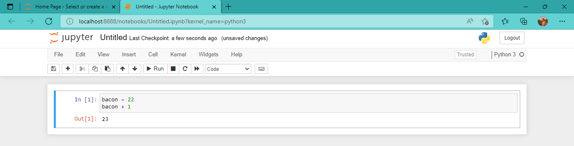
Q7.
Ans: It would print ‘spamspamspam’ in both cases. In first case it is concatenation and in the second case it just multiplies the given word 3 times.
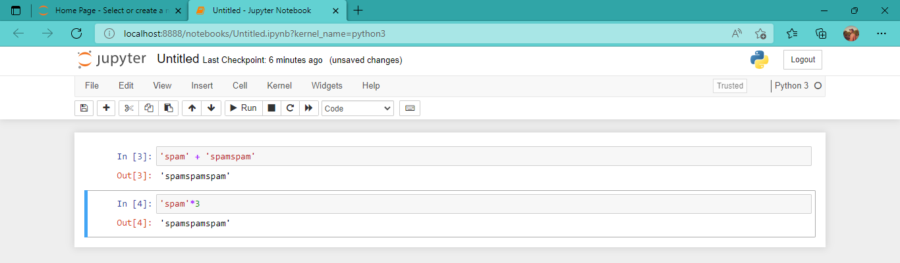

Q8.
Ans: A variable name should always be in character not in an integer because we can’t start giving variable an integer name.

Q9.
Ans: Integer: int ()
Float: float ()
String: str ()

Q10.
Ans: Given code is ‘I have eaten’ + 99 + ‘burritos.’ The given code will produce an error because in between the strings there is an integer and integer cannot be concatenated.

